**TECH HACK**

**Team 7**

**Team Members:**

1. **Dhruv Athaide (Group Leader)**
2. **Shivam Badhopulu**
3. **Sambhav Choudhary**

**Domain: Smart Education**

**GitHub Project Link:** https://github.com/Sammmy22/tech-hack-project

We created two branches in the project linked to above on GitHub. The Client Panel is located in the main branch, and the Admin Panel is located in the Admin-panel Branch. We used React JS and Firebase together, and since the versions and dependencies of the two panels are different, we were compelled to create separate webpages for them.

**Database Schema Diagram:**

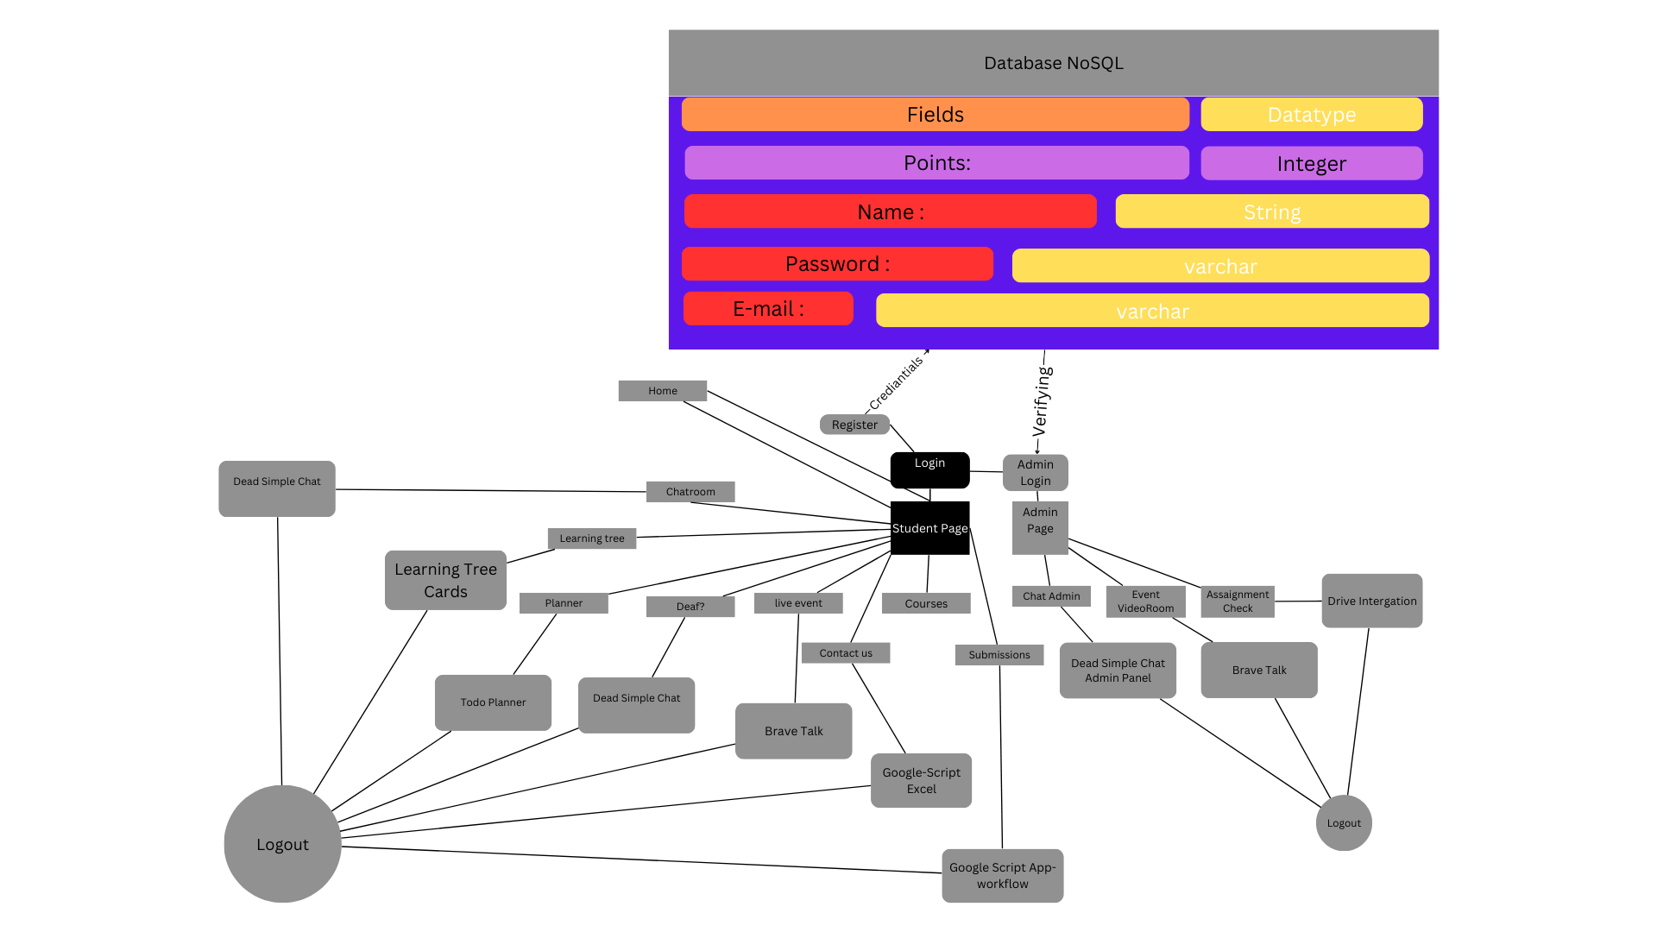

We have also provided the Schema Diagram for our Multilingual ChatBot which we have coded below.

**Multilingual Chatbot Schema Diagram:**

